Kindergarten Maps and Globes Inquiry
Which Is Better, a Map
or a Globe?
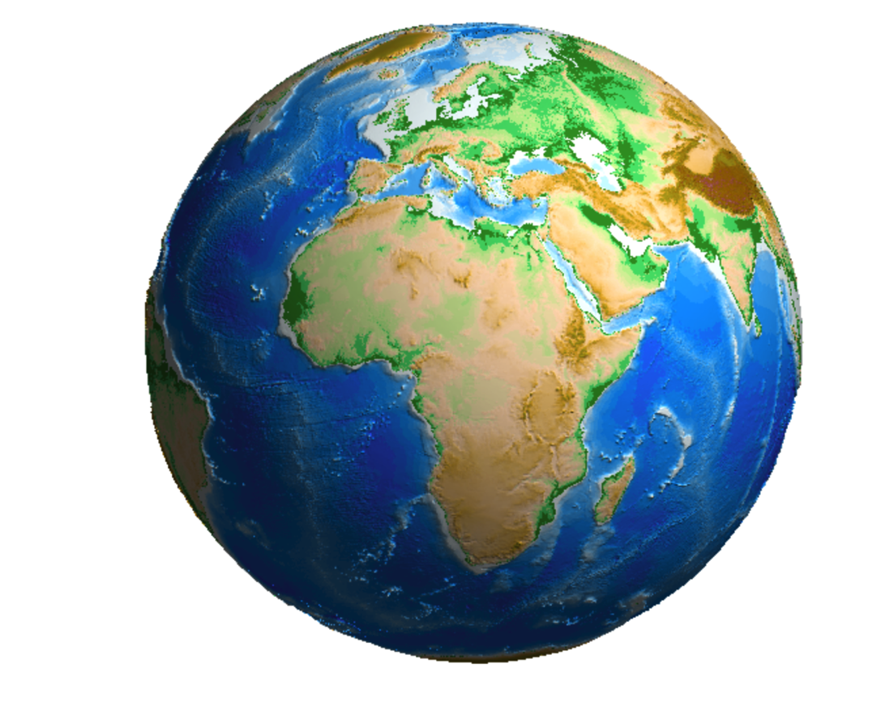

Image courtesy of A. Bezdek, J. Sebera, “MATLAB Script for 3D Visualizing Geodata on a Rotating Globe.”
Computers & Geosciences 56 (2013): 127–130. http://dx.doi.org/10.1016/j.cageo.2013.03.007.

Supporting Questions
- What is a map?
- What is a globe?
- What is the difference between a map and a globe?
- How would you decide to use a map or a globe?

Kindergarten Maps and Globes Inquiry
Which Is Better, a Map or a Globe?
New York State Social Studies Framework Key Idea & Practices | K.6: Maps and globes are representations of Earth’s surface that are used to locate and better understand places and regions.  Gathering, Interpreting, and Using Evidence Comparison and Contextualization Geographic Reasoning
Staging the Question | Pose a question to the class about location, such as “How would we find the post office?” or “How would we figure out the best way to get to the grocery store?” Record students’ ideas on a class chart.

Supporting Question 1 |  | Supporting Question 2 |  | Supporting Question 3 |  | Supporting Question 4
Understand |  | Understand |  | Assess |  | Assess
What is a map? |  | What is a globe? |  | What is the difference between a map and a globe? |  | How would you decide to use a map or a globe?
Formative  Performance Task |  | Formative  Performance Task |  | Formative  Performance Task |  | Formative  Performance Task
Complete the first side of a class chart defining a map and listing its features. |  | Complete the second side of a class chart defining a globe and listing its features. |  | Complete a class Venn diagram identifying the similarities and differences between maps and globes. |  | Complete a sentence starter with illustrations: “I would use a _____ to_______.”
Featured Sources |  | Featured Sources |  | Featured Sources |  | Featured Sources
Source A: Image bank: World maps  Source B: Image bank: Community maps |  | Source A: Image bank: Global images  Source B: Image bank: Geographic features of the Earth |  | Source A: Image bank: Photo, map, and satellite images of the lower Hudson River  Source B: Image bank: Geographic and man-made places |  | Source A: Image bank: Geographic scenarios

Summative Performance Task | ARGUMENT Which is better, a map or a globe? Construct an argument supported with evidence that responds to the compelling question.
Taking Informed Action | ACT Create a map of the school to be used by families or visitors for an open house event.

Overview

Inquiry Description
This inquiry leads students through an investigation of maps and globes as tools that represent the physical world in different ways. In the inquiry, students consider how each tool represents locations, what purposes each tool serves, and what advantages and disadvantages each tool offers. The study of maps and globes provides the foundation for students to develop an understanding of how and why humans interact with geography and geographic features across time and space. The manner in which students gather, use, and interpret evidence should increase their geographic reasoning and allow them to make and support their arguments in response to the compelling question, “Which is better, a map or a globe?”
In addition to the Key Idea listed earlier, this inquiry highlights the following Conceptual Understandings:
- (K.6a) A globe represents Earth, and maps can be used to represent the world as well as local places or specific regions.
- (K.6b) Places and regions can be located on a map or globe, using geographic vocabulary.
- (K.6c) Places, physical features, and man-made structures can be located on a map or globe and described using specific geographic vocabulary.
In this inquiry, the Taking Informed Action sequence is embedded. The understand element is represented through Supporting Questions 1 and 2, in which students examine the difference between maps and globes. Students assess the relative value of maps and globes in Supporting Questions 3 and 4. The act experience may be accomplished either in addition to, or as a substitute for, the Summative Performance Task.
NOTE: This inquiry is expected to take four to six 30-minute class periods. The inquiry time frame could expand if teachers think their students need additional instructional experiences (i.e., supporting questions, formative performance tasks, and sources). Teachers are encouraged to adapt the inquiries to meet the needs and interests of their particular students. Resources can also be modified as necessary to meet individualized education programs (IEPs) or Section 504 Plans for students with disabilities.
NOTE: If an actual map is not available, an atlas or trade book may be used to supplement the images in the image banks. Likewise, if an actual globe is not available, Google Earth (https://www.google.com/earth/ ) or a trade book may be used to supplement the images of globes in the featured sources.

Structure of the Inquiry
In addressing the compelling question “Which is better, a map or a globe?” students work through a series of supporting questions, formative performance tasks, and sources in order to construct an argument with evidence from a variety of sources.

Staging the Compelling Question
As an opening exercise for this inquiry, teachers might pose a question to the class about location, such as “How would we find the post office?” or “How would we figure out the best way to get to the grocery store?” Teachers should record students’ ideas on a class chart.

Supporting Question 1
The first supporting question—“What is a map?”—helps students understand that maps are one way to represent the idea of place. The formative performance task calls on students to develop a class definition of a map and to list the features of a map on one side of a class-developed chart. Featured Source A provides students with two different world maps to give them an opportunity to identify common features of a map, while Featured Source B shows students two kinds of community maps, which suggests that maps can represent locations in different ways.

Supporting Question 2
The second supporting question—“What is a globe?”—allows students to build on their understandings of maps by developing the idea that globes are also representations of place. The second formative performance task calls on students to add to the class chart begun in the first performance task by defining the word “globe” and listing its features. Featured Sources A and B present students with various images of globes to build their understandings of globes as three-dimensional representations that provide a different perspective than a map does.

Supporting Question 3
The third supporting question—“What is the difference between a map and a globe?”—prompts students to begin making generalizations about the potential uses of maps and globes. Building on their previous definitions and descriptions of the features of each tool, this formative performance task calls on students to compare and contrast the uses of maps and globes by completing a class-developed Venn diagram. Working with Featured Source A, students see the relative value of photographs, maps, and satellite images by looking at a common location through those representations. Featured Source B provides an opportunity for students to analyze a variety of images of geographic and man-made features and attempt to search for each on a map and a globe.
NOTE: If this is the first time students have worked with a Venn diagram, teachers may want to begin with the class chart from Supporting Questions 1 and 2 and transfer that information onto a Venn diagram.

Supporting Question 4
Having examined a variety of maps and globes, students wrestle with the final supporting question—“How would you decide to use a map or a globe?”—and develop a purpose statement for the use of each tool. The featured source provides opportunities for students to assess which tool would be the most helpful to answer the questions posed in the scenarios provided. The formative performance task calls on students to choose a scenario, represent their answers through an illustration, and then explain their ideas (and why they chose them) to a small group.

Summative Performance Task
At this point in the inquiry, students have worked with a variety of sources to understand the geographic purposes and representational advantages and disadvantages of maps and globes. This work enables students to begin developing an understanding of place. Students should be expected to demonstrate the breadth of their understandings and their abilities to use evidence from multiple sources to support their arguments. Students might cite evidence for their arguments in a variety of developmentally appropriate ways. For example, teachers might record arguments on a class chart as students share, or students might voice their arguments through a verbal exchange in a small group.
Students’ arguments likely will vary, but could include any of the following:
- A map is better when you are going someplace because you will need to take it with you. It would be too hard to carry a globe on a trip.
- A map is better when you need to know the names of the towns and streets because a globe doesn’t have the names of towns and streets on it.
- A globe is better when you want to see what the world looks like from space because a map is flat and doesn’t look real.
- A globe is better when you want to see the North Pole and the South Pole in the correct places, because a flat map can’t show them the way they really look from space.
- Maps and globes are both good, because each one is better sometimes and not other times.
- Maps and globes are both good, because it’s important to know what the whole world looks like, and it’s important to know how to get places.
Students have the opportunity to Take Informed Action by using the information from the inquiry to create a map of the school to be used by families or visitors attending an open house event.

Supporting Question 1
Featured Source | Source A: Image bank: World maps showing different features

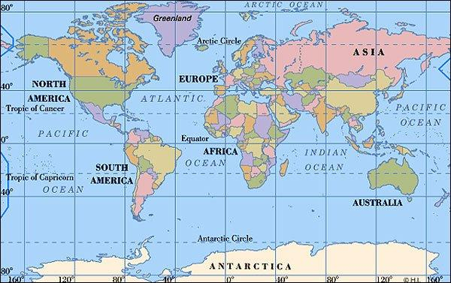
Image 1: World political map.
© freeworldmaps.net. http://kolahun.typepad.com/.a/6a00e009968c0a8833014e8931d3da970d-800wi.

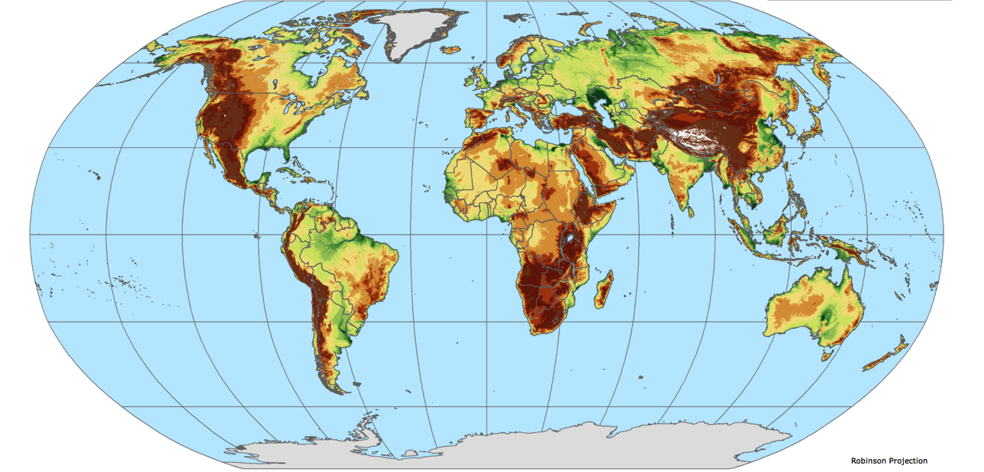

Image 2: World landform map.
© 2012. The Trustees of Columbia University in the City of New York. http://sedac.ciesin.columbia.edu/downloads/maps/nagdc/nagdc-population-landscape-climate-estimates-v3/place3-elevationzones-global.pdf.

Supporting Question 1
Featured Source | Source B: Image bank: Community maps showing different features
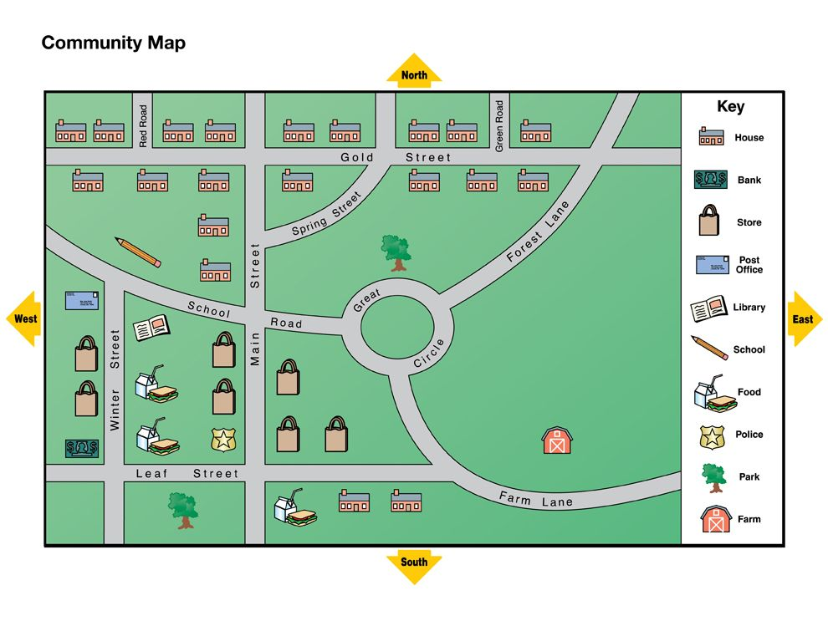
Image 1: Community map.
Map courtesy of National Geographic and Cengage Learning.

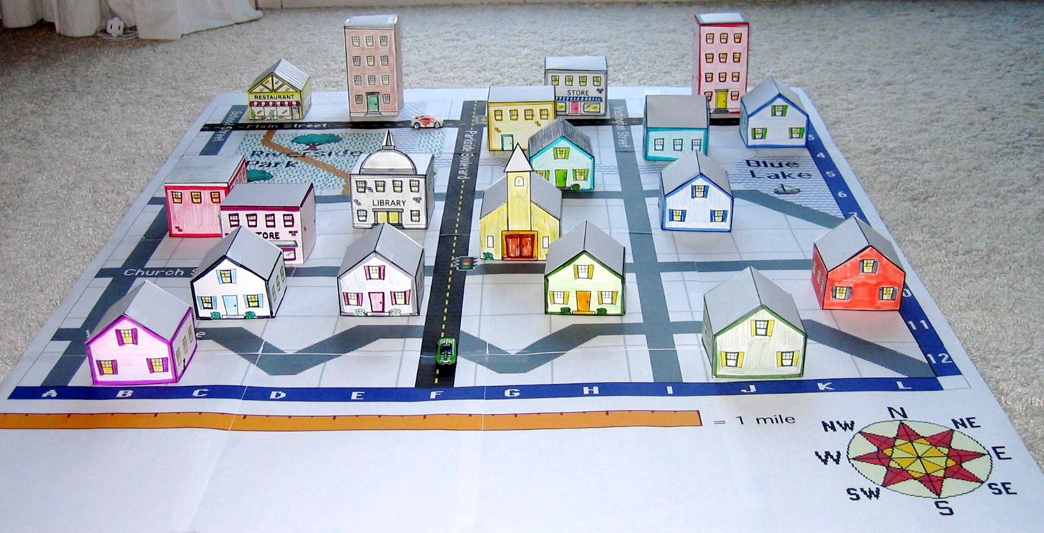
Image 2: Three-dimensional neighborhood map.
© Peggy Healy Sterns. Create a 3D Town & Nurture Young Explorers. Used by permission from Parents’ Choice. http://www.parents-choice.org/download/ParentsChoiceMap.jpg.

Supporting Question 2
Featured Source | Source A: Image bank: Global images

Image 1: Globe showing physical features.
Image courtesy of A. Bezdek, J. Sebera, “MATLAB Script for 3D Visualizing Geodata on a Rotating globe.”
Computers & Geosciences 56 (2013): 127–130. http://dx.doi.org/10.1016/j.cageo.2013.03.007.

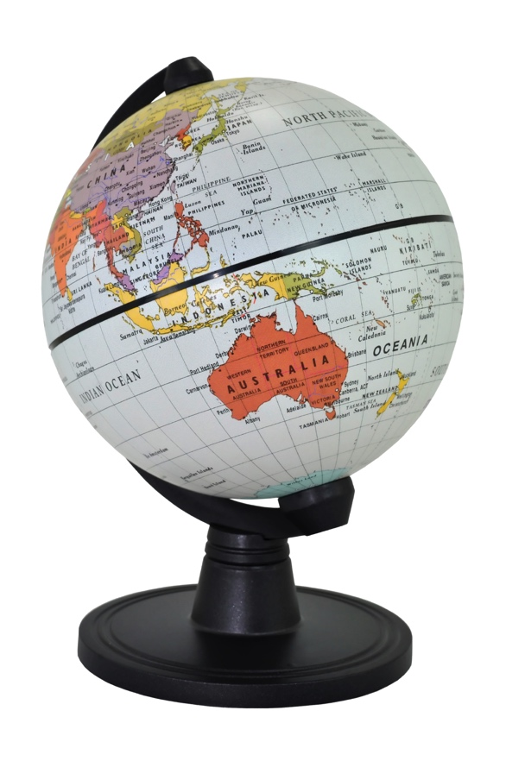
Image 2: Globe showing political features.
© istock/© BluesandViews.

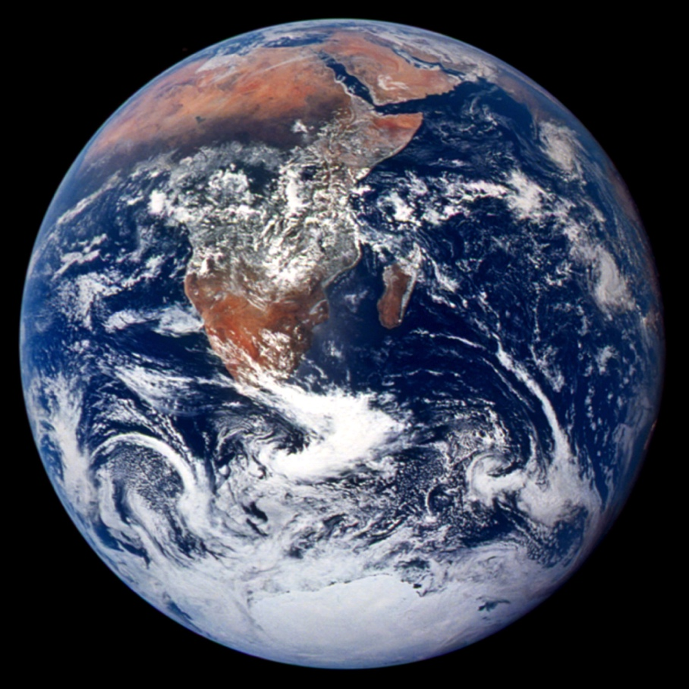

Image 3: Earth, as seen from space.
Public domain. Image courtesy of NASA.

Supporting Question 2
Featured Source | Source B: Image bank: Geographic features of the Earth

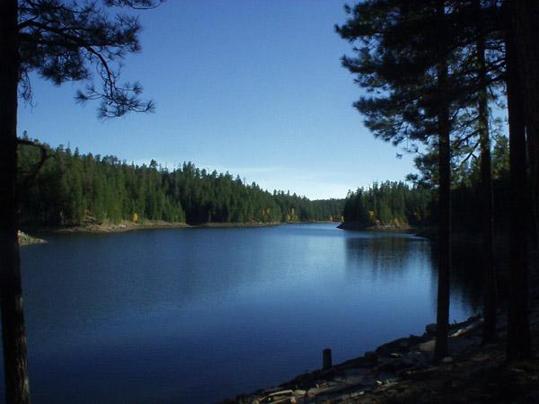
Image 1: Body of water.
Public domain. US Department of Agriculture. http://www.fs.usda.gov/Internet/FSE_MEDIA/stelprdb5301075.jpg.

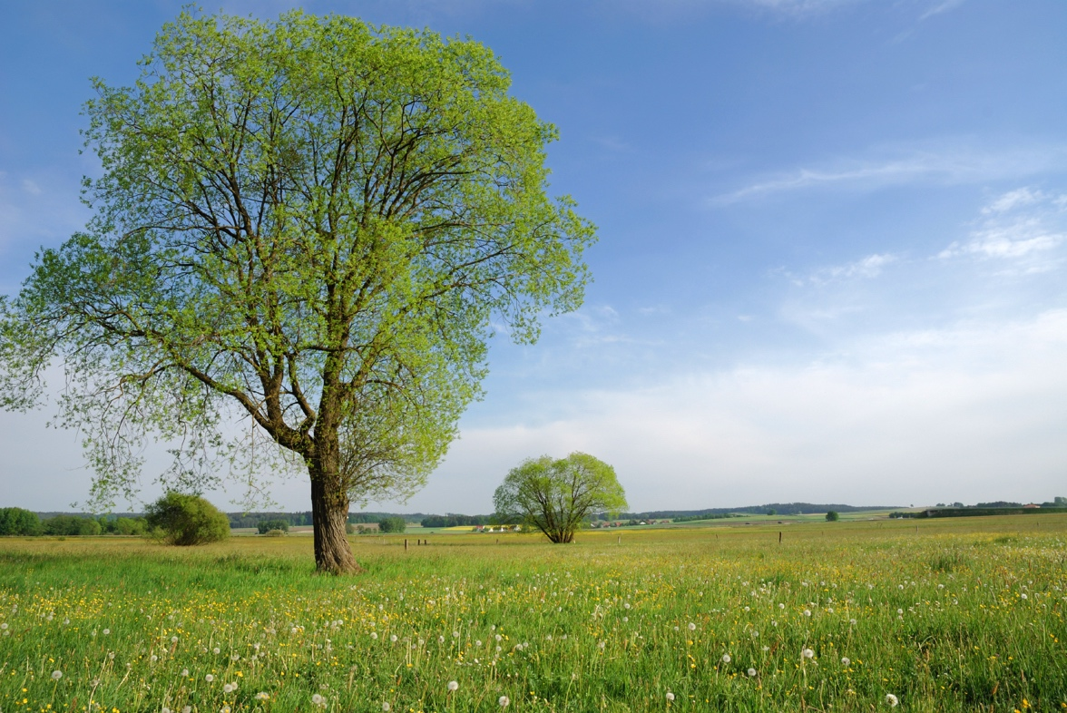
Image 2: Land.
© istock/© manfredxy.
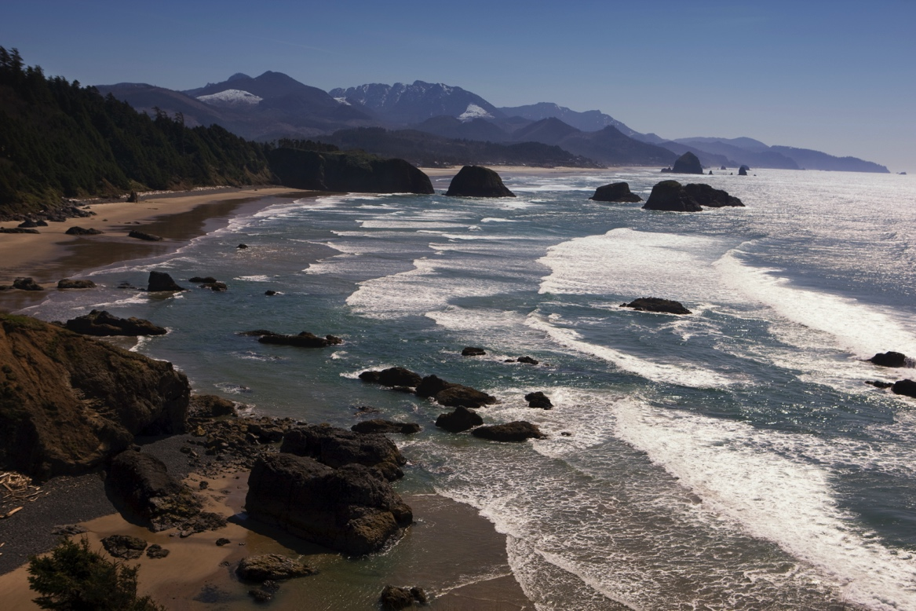
Image 3: Ocean.
© istock/© CinematicFilm.

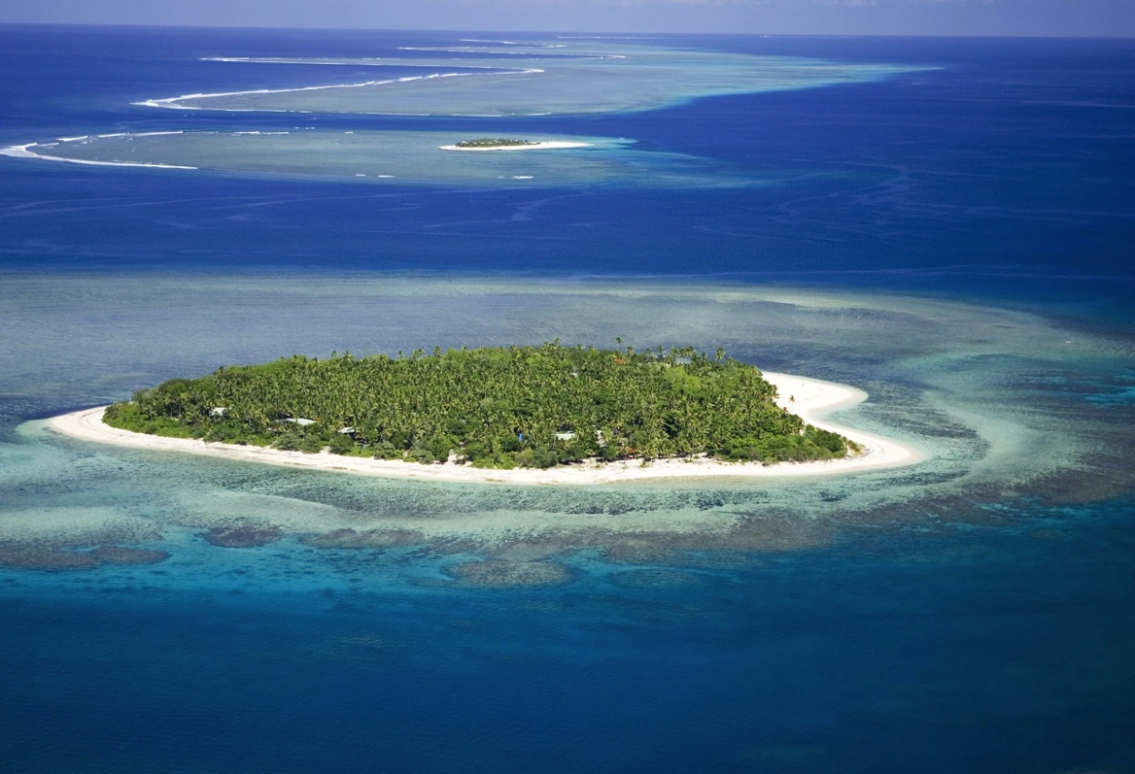
Image 4: Island.
Used under Creative Commons License. Photo by Tavyland.

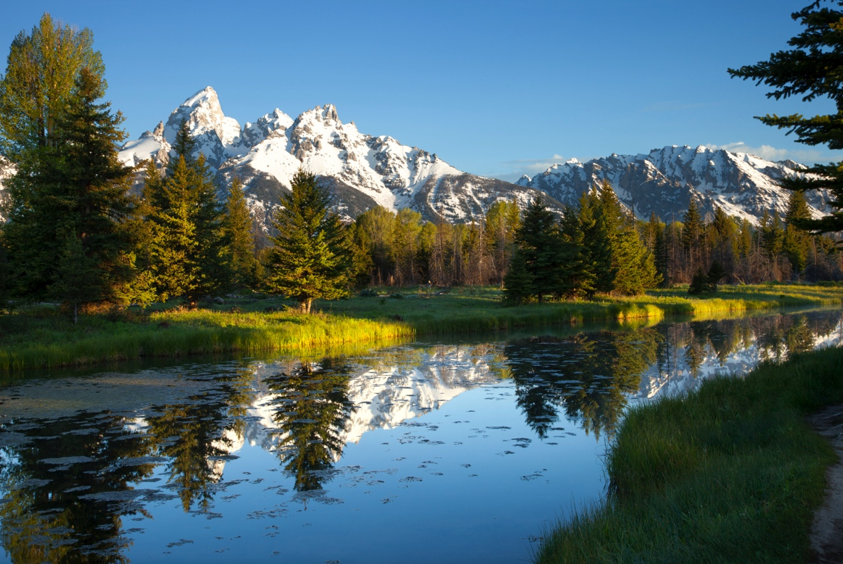
Image 5: Mountain.
© istock/© Willard.

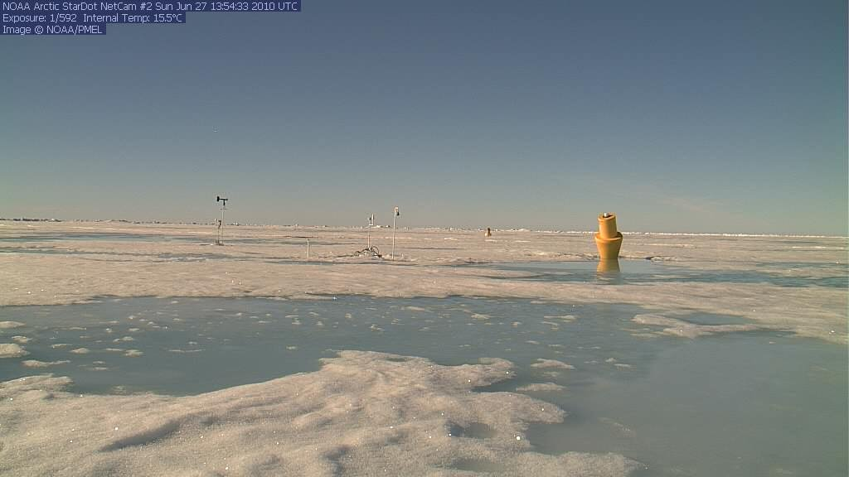
Image 6: North Pole.
Public domain. Courtesy of NOAA News 031611.

Supporting Question 3
Featured Source | Source A: Image bank: Photo, map, and satellite images of the lower Hudson River

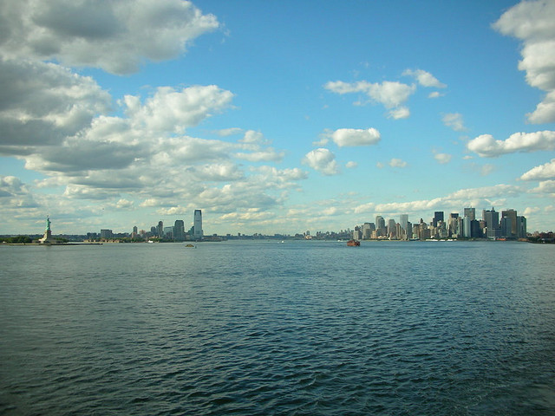
Image 1: Photograph of the lower Hudson River.
Used under Creative Commons license. Photo by Tom Mascardo. https://www.flickr.com/photos/mascardo/747993122.

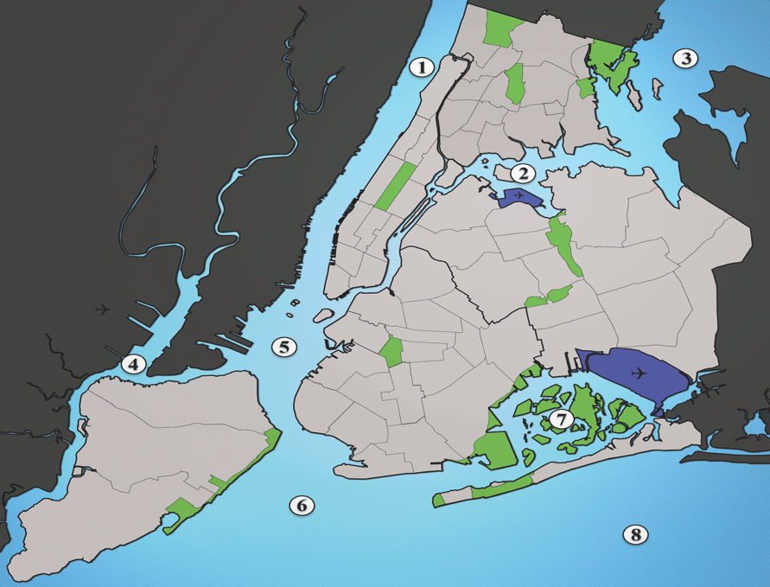
Image 2: Map of the lower Hudson River. Key to Hudson River estuary waterways: (1) Hudson River, (2) East River, (3) Long Island Sound, (4) Newark Bay. (5) upper New York Bay, (6) lower New York Bay, (7) Jamaica Bay, and (8) Atlantic Ocean.
Used under Creative Commons license. Image by Julius Schorzman. http://upload.wikimedia.org/wikipedia/commons/7/71/Waterways_New_York_City_Map_Julius_Schorzman.png.

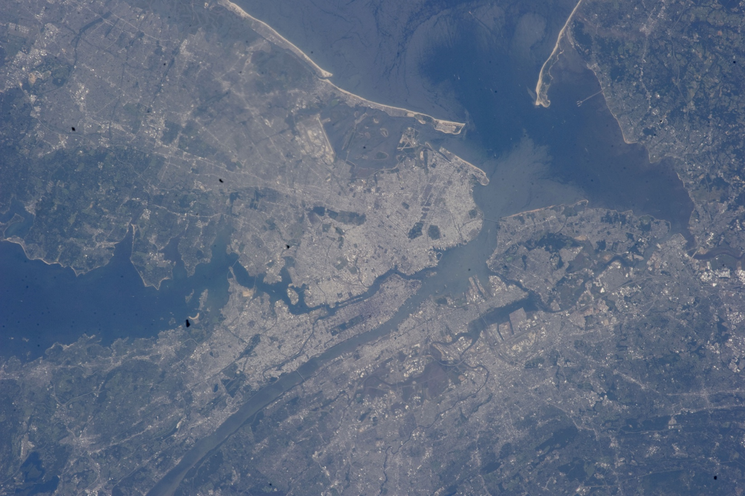
Image 3: Satellite image of the lower Hudson River.
Public domain. Courtesy of NASA.

Supporting Question 3
Featured Source | Source B: Image bank: Geographic and man-made places

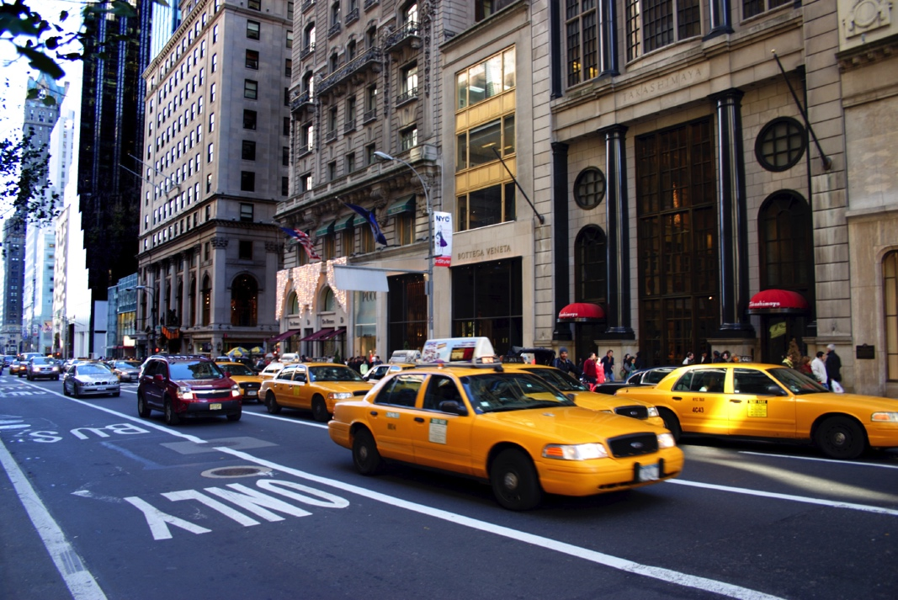
Image 1: Street.
©istock/© coloeong

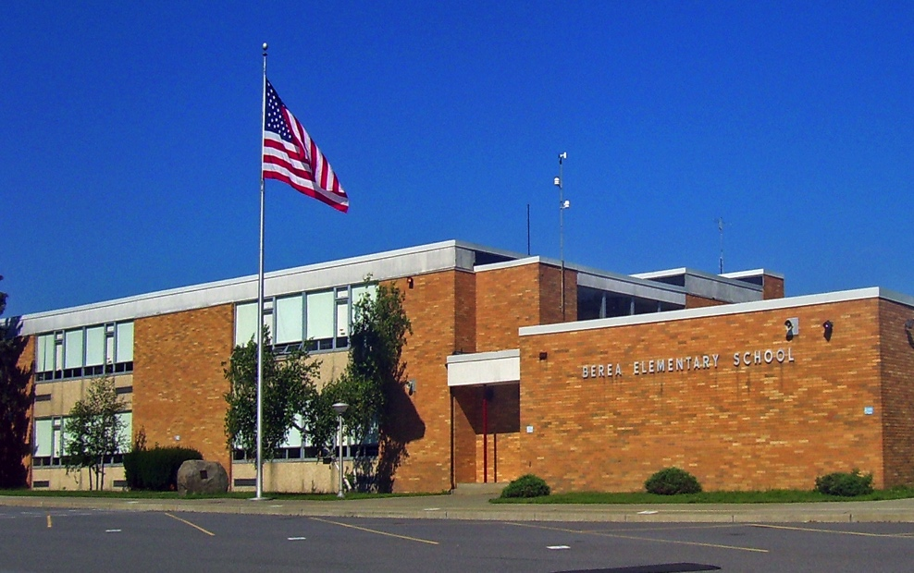
Image 2: School.
Used under Creative Commons license. Image by Daniel Case. http://commons.wikimedia.org/wiki/File:Berea_Elementary_School,_Montgomery,_NY.jpg.

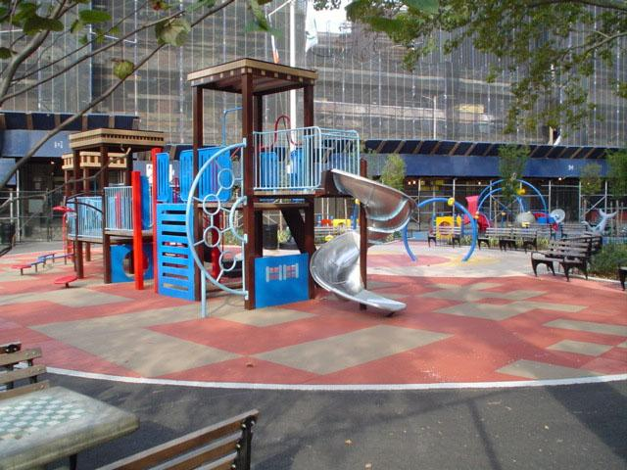
Image 3: Park.
© Copyright New York City Department of Parks & Recreation. http://www.nycgovparks.org/photo_gallery/full_size/20062.jpg.

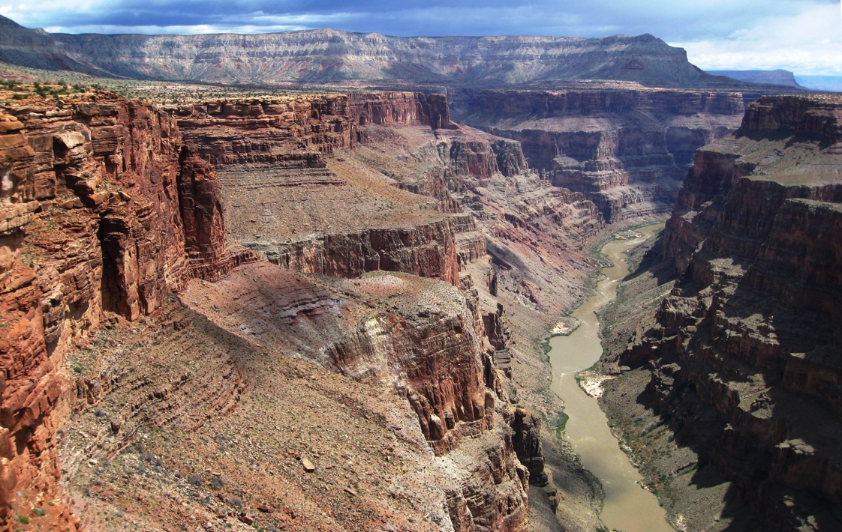
Image 4: Grand Canyon.
Used under the Creative Commons license. http://upload.wikimedia.org/wikipedia/commons/5/5a/Grand_Canyon.jpg.

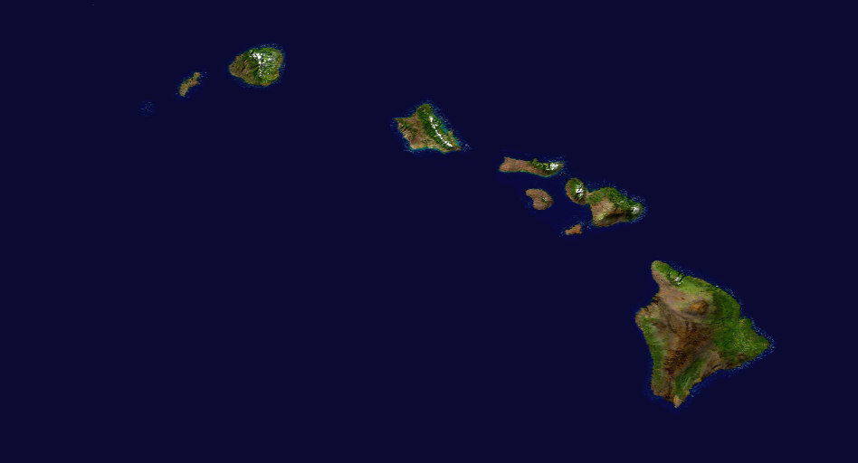
Image 5: Hawaiian Islands.
Public domain. Courtesy of NASA. Image by Jeff Schmaltz, MODIS Rapid Response, Goddard Space Flight Center.

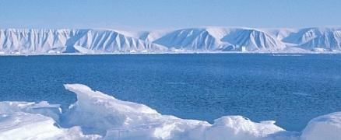
Image 6: Arctic Ocean.
Courtesy of NASA, GRACE team, DLR. Photo by Ben Holt Sr.

Supporting Question 4
Featured Source | Source A: Image bank: Geographic scenarios

Map versus Globe Scenarios

Image 1: You are taking an airplane trip to Australia and want to see if you will be flying over any large bodies of water. Would you use a map or a globe? Why?
© istock/© mikessss.

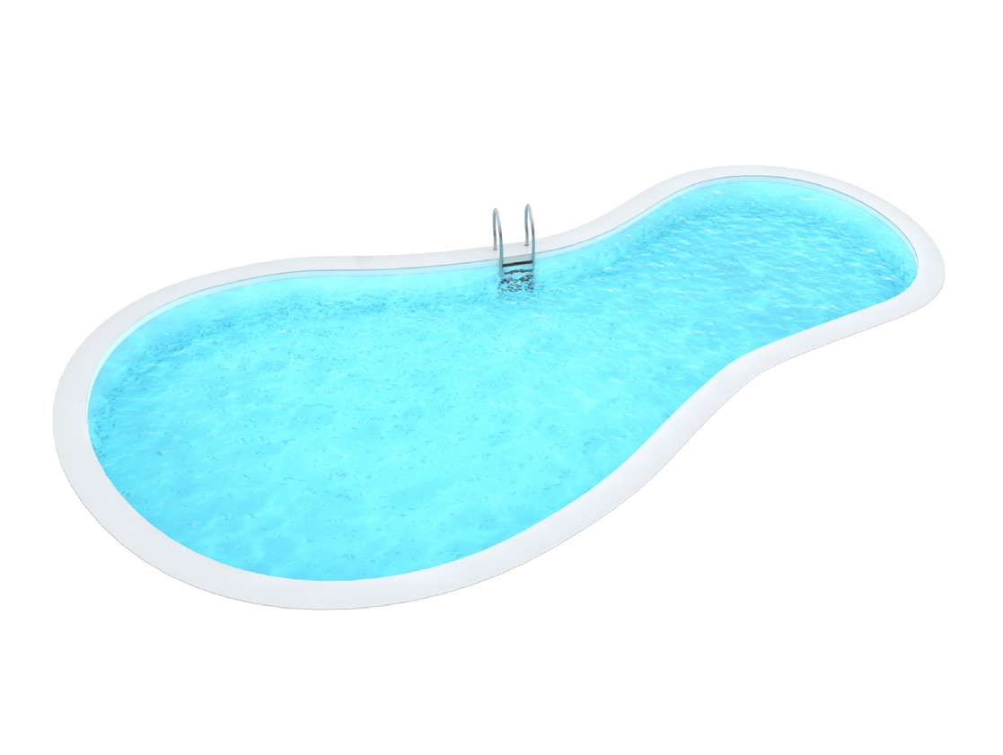
Image 2: You have been invited to a pool party and need to figure out the directions to get to the community center. Would you use a map or a globe? Why?
© istock / © RakicN.

Image 3: You are curious about which parts of the Earth have mountains. Would you use a map or a globe? Why?
© istock / © MrsWilkins.

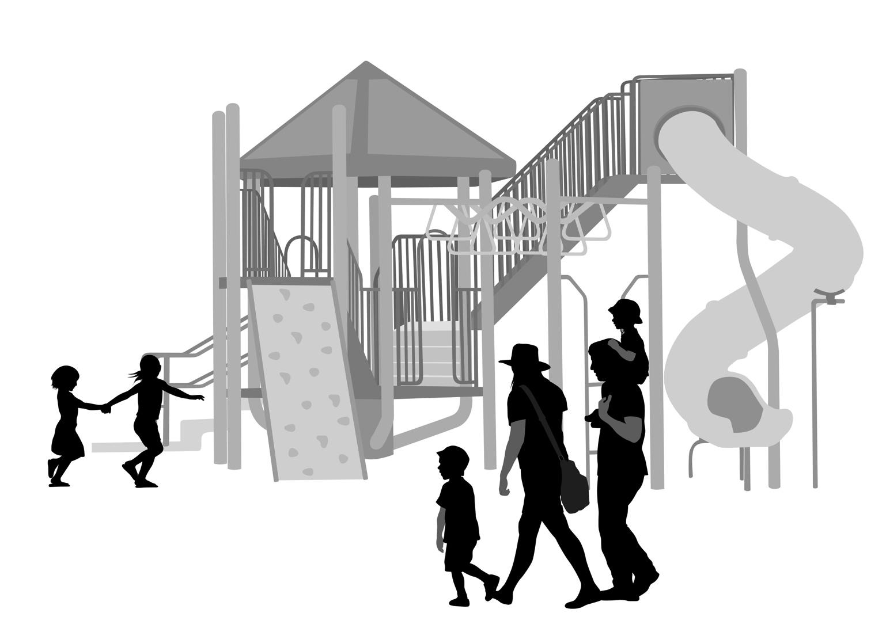

Image 4: You are trying to decide which playground is closer to your home. Would you use a map or a globe? Why?
© istock / © A-Digit.

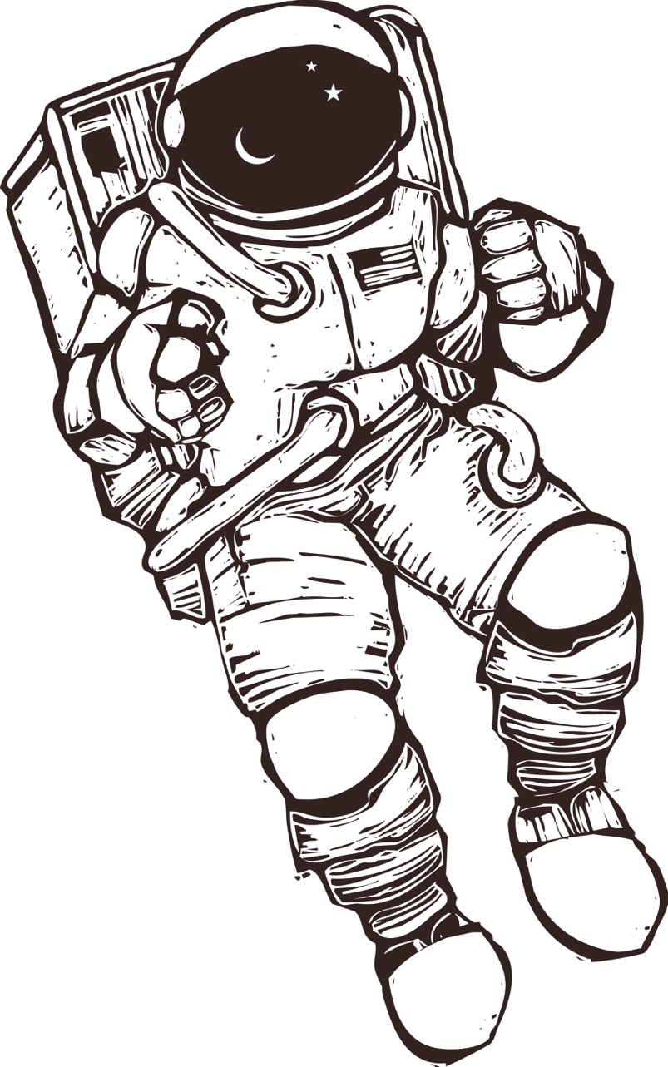

Image 5: You are curious about what astronauts see when they look at Earth from their spacecraft. Would you use a map or a globe? Why?
© istock / © xochicalco.

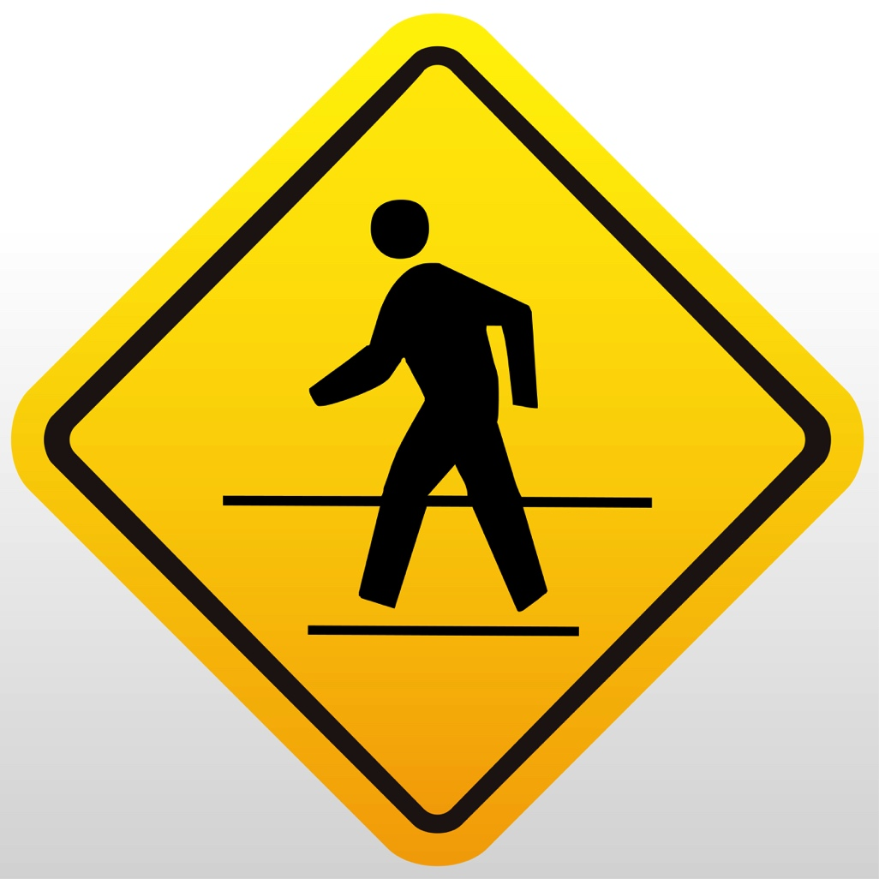

Image 6: You are taking a hike in a park you’ve never been to before. Would you use a map or a globe? Why?
© istock / © Graphic_photo.

