Tally Practice Time

Work as a team to see how many tallies
you can complete using the sticks in your bag.

Follow this example:
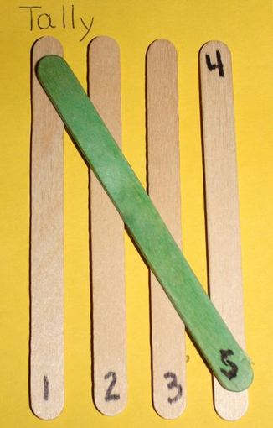

When you are finished,
complete the data sheet as a team.

Name_______________________________________

Tally Practice Time Data Sheet

How many tallies did you make from the sticks in your bag? | What are two different ways  to show this number?

Name_______________________________________

Tally Practice Time Data Sheet

How many tallies did you make from the sticks in your bag? | What are two different ways  to show this number?

