A Staircase Summary
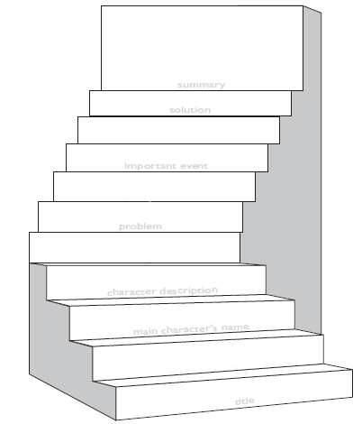

Name_______________________________

__________________ wanted _________________

__________________________________________

but_______________________________________

__________________________________________

So________________________________________

__________________________________________

Then______________________________________

__________________________________________

__________________________________________

