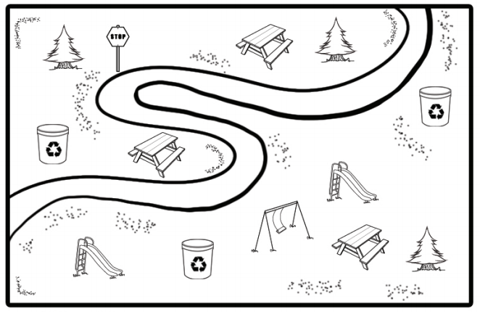

|  |  |
| --- | --- |
|  |  |
|  |  |

|  |  |
| --- | --- |
|  | **NE** |
| **SW** | **SE** |
|  |  |
|  |  |

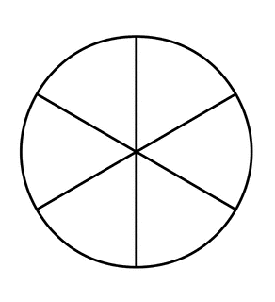

**SE NE**

**NW SW**

**SE NW .**







     

     

     

     

     

     