Mini-Book Introduction to Latitude and Longitude

Teacher Prep:
- Copy page 1 on cardstock. 1 page for every 2 students
- Copy pages 2 and 3 on cardstock or copy paper 1 page for every 2 students
- Copy page 4 on cardstock or copy paper 1 page for each student
- Create a sample book.

Materials Needed:
- Classroom globe
- Copies listed above
- Scissors, glue, and crayons or colored pencils
- Teacher-created sample book
- Recommended- vocabulary and picture cards

OK Social Studies Standards Targeted:
    - Construct basic maps… including the introduction of latitude and longitude and the division of the Earth into four hemispheres.

Instructional Recommendations:
- Second grade students will benefit if this activity is split into two days. (Day 1- Step 1&2 Day 2- Step 3&4)
Splitting the activity this way will limit the number of new vocabulary words introduced in a single lesson.
Students more successfully differentiate between latitude/longitude when the skills are introduced separately.

- Utilizing vocabulary picture cards and/or images of the globe divided by latitude/longitude will support student learning.

- In order to maximize instructional time, it may be beneficial to ask volunteers to do the cutting for this activity ahead of time.

- The shading of the book covers should be completed during the review of key words and concepts. Instructional time cannot be spent simply coloring.

Instructional Plan

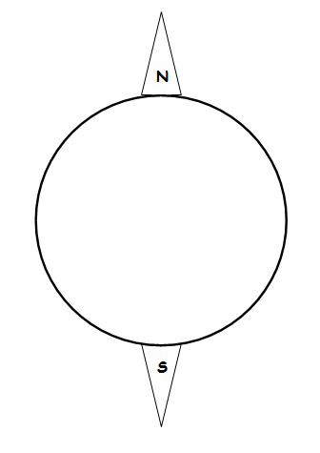
Step 1:

Key vocabulary in this step:
- globe, sphere, earth, latitude, longitude, cardinal directions, north, south

The teacher will:
- Give each student page 1- the base circle with the North and South Poles.
- Using a globe, remind students that the earth is actually shaped like a sphere.
- Explain that one side of a sphere- is shown as a circle.
- Tell them that the base circle represents the earth.
- Discuss the North and South Poles as the top and bottom points of the earth.
- Explain that during the lesson we will add circles on top of this base as we
study how people divide the earth using lines called latitude and longitude.

During the discussion the students will:
- Cut out the base circle- leaving the triangles for the poles attached.
- Label the North Pole “N” and the South Pole “S.”
- Write their name on the back of this circle.

Step 2:

Key vocabulary in this step:
- imaginary, vertical, hemisphere, longitude, east, west, Prime Meridian

The teacher will:
- Give each student page 2- the circle that is split into the Eastern and Western Hemispheres.
- Help each student turn their circle so that the line is vertical.
- Refer to the N and S already labeled and prompt students to remember the other two cardinal directions.
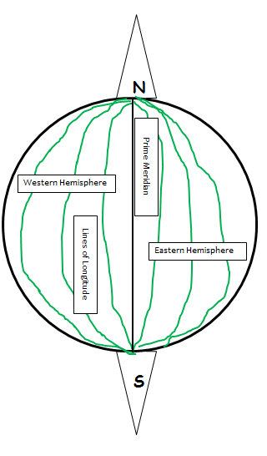
- Discuss:
  - In order to make it easier to find locations on the globe,
people divide the earth with imaginary lines.
  - Imaginary vertical lines of longitude are used to divide the earth
into east and west sections.
  - The “starting point” for lines of longitude is called the Prime Meridian.
  - The other lines of longitude are used to show how far a place is from
that starting point.
  - The Prime Meridian splits the earth in half east to west.
  - Half of the earth is called a hemisphere.
  - The Prime Meridian creates the Eastern and Western Hemispheres.

During the discussion the students will:
- Cut out the circle.
- Glue or tape the circle to the left edge of the base circle
so that opens like a book.
- Follow the teacher’s sample and draw other lines of longitude.
- Cut out the labels on page 2.
- Follow the teacher’s sample and glue the labels in the correct places.

Step 3:

Key vocabulary in this step:
- imaginary, horizontal, hemisphere, latitude, north, south, Equator

The teacher will:
- Give each student page 3- the circle that is split into the Northern and Southern Hemispheres.
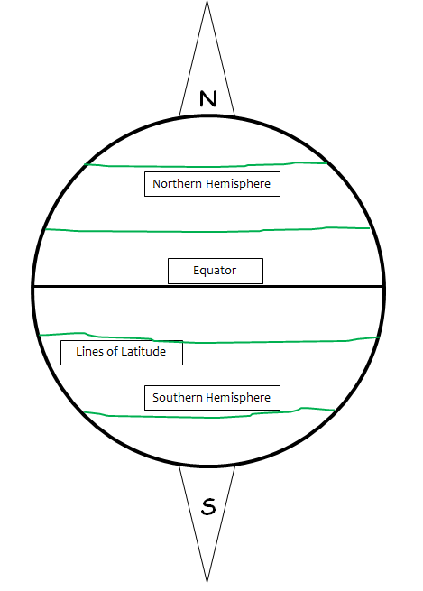
- Help each student turn their circle so that the line is horizontal.
- Discuss:
  - In order to make it easier to find locations on the globe,
people divide the earth with imaginary lines.
  - Imaginary horizontal lines of latitude are used to divide the earth
into north and south sections.
  - The “starting point” for lines of latitude is called the Equator.
  - The other lines of latitude are used to show how far a place is
from that starting point.
  - The Equator splits the earth in half north to south.
  - Half of the earth is called a hemisphere.
  - The Equator creates the Northern and Southern Hemispheres.

During the discussion the students will:
- Cut out the circle.
- Glue or tape the circle to the left edge of the previous page
so that opens like a book.
- Follow the teacher’s sample and draw other lines of latitude.
- Cut out the labels on page 3.
- Follow the teacher’s sample and glue the labels in the correct places.

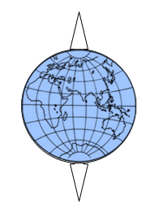

Step 4:

Review key vocabulary:
- globe, sphere, earth, latitude, longitude, hemisphere,
north, south, east, west

The teacher will:
- Give each student page 4- the globe with latitude and longitude marked.
- Revisit the globe and review that the earth is actually shaped like a sphere.
- Review the key vocabulary through discussion of key concepts.

During the discussion the students will:
- Shade the continents and oceans.
- Cut out the two circles.
- Glue or tape the circles to the previous pages to create a front and back
cover for the booklet.

https://practicalpages.wordpress.com/2010/07/31/geography-learn-about-hemispheres-minibook/
Idea adapted to meet Oklahoma 2nd grade standards.
Page 1
Base Circle

Page 1
Base Circle

Page 2
Western & Eastern Hemispheres

Western Hemisphere
Eastern Hemisphere
Prime Meridian
Lines of Longitude

Page 2
Western & Eastern Hemispheres

Western Hemisphere
Eastern Hemisphere
Prime Meridian
Lines of Longitude

Page 3
Northern & Southern Hemispheres

Northern Hemisphere
Southern Hemisphere
Equator

Page 3
Northern & Southern Hemispheres

Northern Hemisphere
Southern Hemisphere
Equator
Lines of Latitude

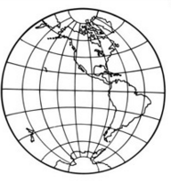
Page 4
Front and Back Cover
Each student needs both circles.

