PARTNER READING
LOOKS LIKE | SOUNDS LIKE 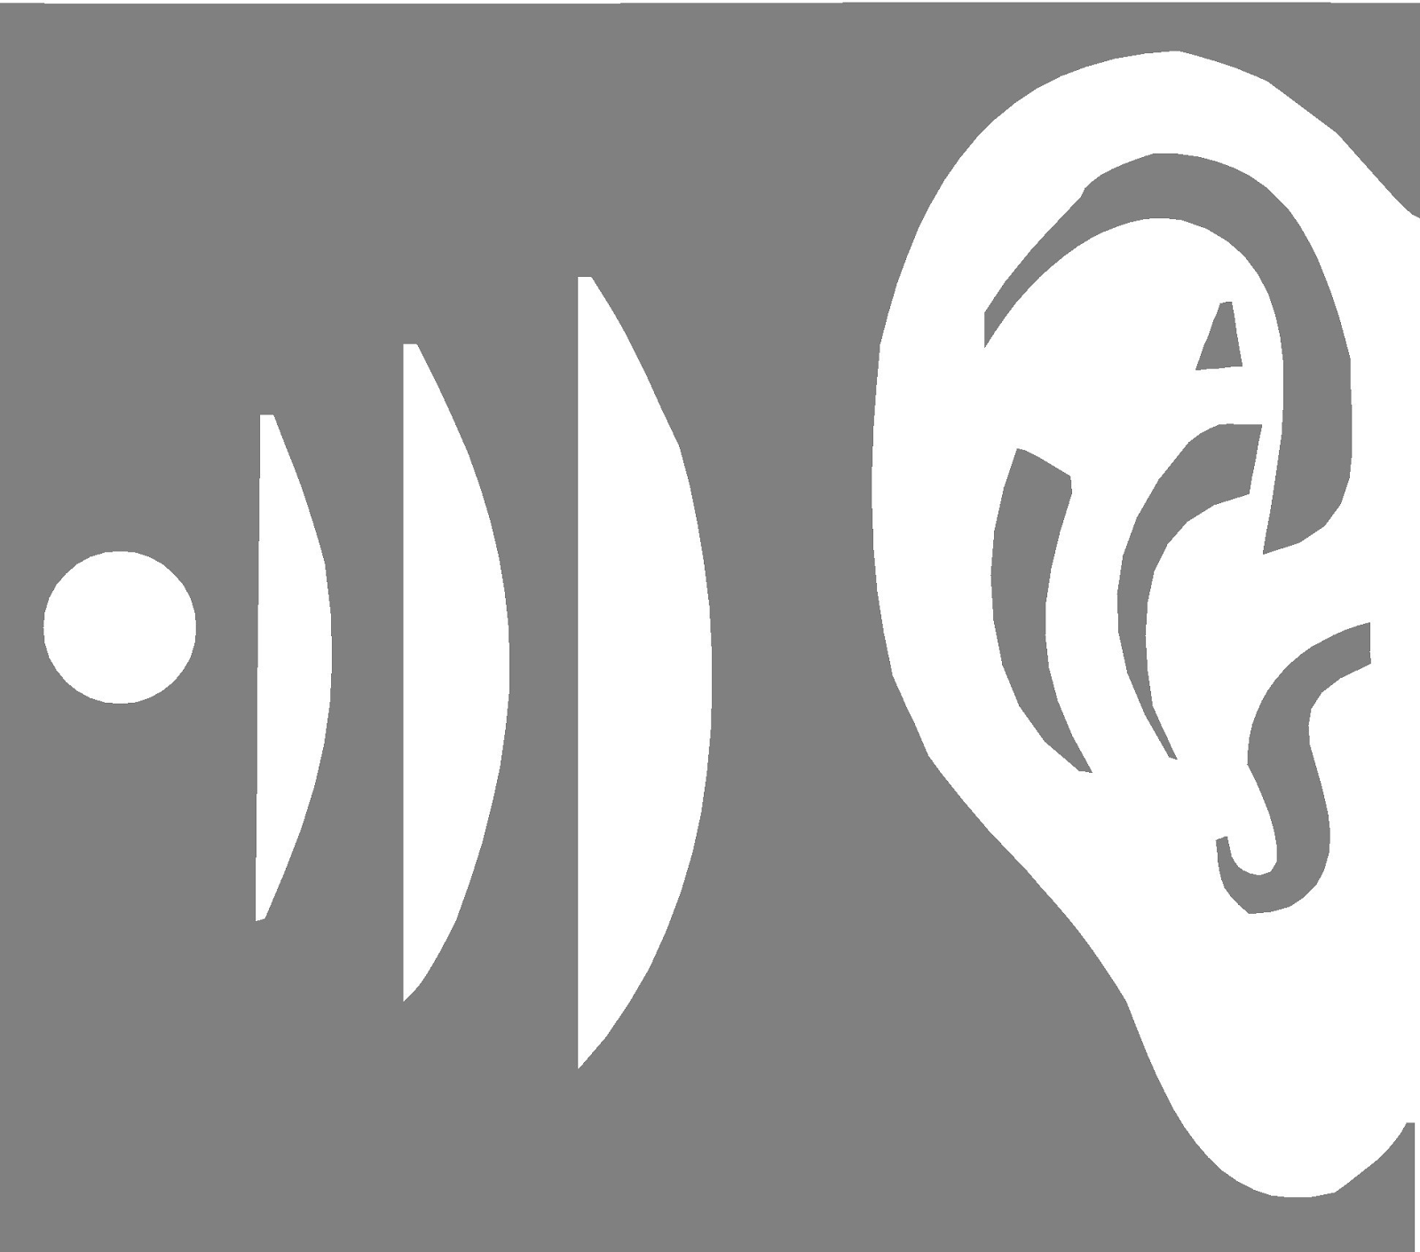
- Walking to a reading place  - One partner facing one wall of the room and one partner facing the opposite wall with timer in hand  - Chairs and knees are side by side and almost touching  - Reader’s and listener’s fingers or markers are following along. | - Soft voices  - Only your partner can hear you.  - One voice at a time.  - Timer sounds, count words, check rubric, and 2 minute “Partner Talk” or answer comprehension questions.

Rubric for Partner-Reading
Score | Smoothness | Accuracy | Expression
1 | Many long pauses between words | Missed 5 or more words | Monotone voice
2 | Some long pauses between words | Missed 3 or 4 words | Changes voice for expression sometimes
3 | No long pauses between words | Missed no more than 2 words | Changes voice to express meaning

YOUR FLUENCY JOURNAL LOOKS LIKE:
Date:___________________  Words Read:  # of Words Missed:  WPM: | Partner Names:  1._________________________________  2._________________________________  Smoothness:____________ out of 3.  Accuracy:______________ out of 3.  Expression:_____________ out of 3.  Total for Partner #1:_________ out of 9.

modified from K12Reader - http://www.k12reader.com

