American Symbols Summary Sheet

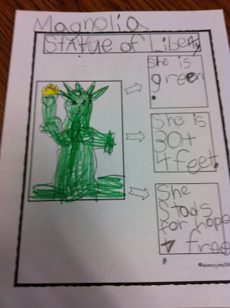

This idea was found here:
http://mrswilliamsonskinders.blogspot.com/2011/03/america-unit.html

The next page provides the summary template.

