KISS your brain!
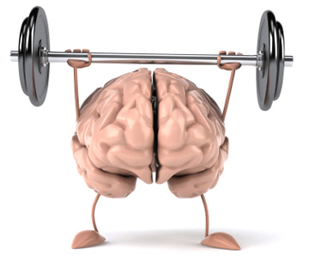
You’re ready for this!

KISS your brain!
You’re ready for this!

KISS your brain!
You’re ready for this!

KISS your brain!
You’re ready for this!
KISS your brain!
You’re ready for this!

KISS your brain!
You’re ready for this!

KISS your brain!
You’re ready for this!

KISS your brain!
You’re ready for this!
KISS your brain!
You’re ready for this!

KISS your brain!
You’re ready for this!

KISS your brain!
You’re ready for this!

KISS your brain!
You’re ready for this!
KISS your brain!
You’re ready for this!

KISS your brain!
You’re ready for this!

KISS your brain!
You’re ready for this!

KISS your brain!
You’re ready for this!
KISS your brain!
You’re ready for this!

KISS your brain!
You’re ready for this!

KISS your brain!
You’re ready for this!

KISS your brain!
You’re ready for this!
KISS your brain!
You’re ready for this!

KISS your brain!
You’re ready for this!

KISS your brain!
You’re ready for this!

KISS your brain!
You’re ready for this!
KISS your brain!
You’re ready for this!

KISS your brain!
You’re ready for this!

KISS your brain!
You’re ready for this!

KISS your brain!
You’re ready for this!
KISS your brain!
You’re ready for this!

KISS your brain!
You’re ready for this!

KISS your brain!
You’re ready for this!

KISS your brain!
You’re ready for this!

