Read the books.
Find words that fit into each vowel group.
Write the words on your paper.
Remember theses short voewl cues as you begin your search!
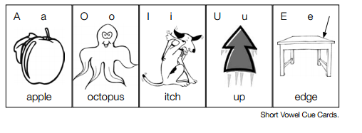
Remember theses short voewl cues as you begin your search!
Remember theses short voewl cues as you begin your search!

