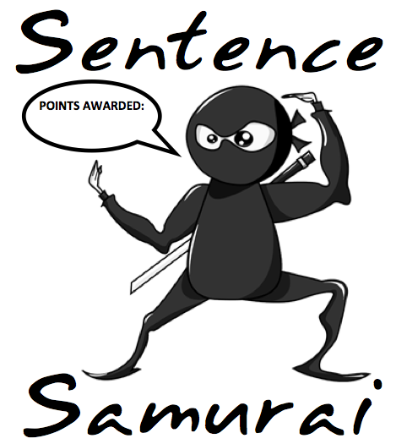
Hit me with
your best sentence!

Your challenge is to be a true samurai of sentence construction- using any of the words given, only once, to create the lengthiest, meaningful sentence possible. Record your final sentence. Be sure to use proper grammar, capitalization, and punctuation.

Earning Points:
Each word with 3 or fewer letters = 1 point
Each word with 4 or more letters = 3 points
Each grammatical mistake = lose 1 point

