Comprehension Cubes
1. Take turns reading the text aloud with your partner.
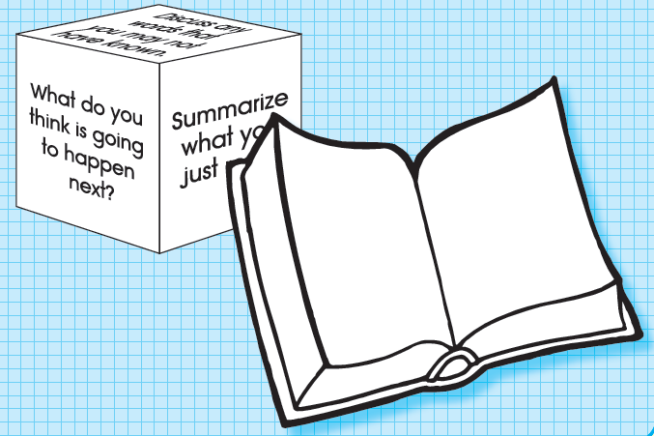
2. Roll the question cube, read the question, . and answer it based on the text.
3. Discuss the answer with your . partner and record.
6. Continue the activity until all the . . questions are answered at least once.

Comprehension Cubes
1. Take turns reading the text aloud with your partner.
2. Roll the question cube, read the question, . and answer it based on the text.
3. Discuss the answer with your . partner and record.
6. Continue the activity until all the . . questions are answered at least once.

