Shades of Meaning
This vocabulary activity helps students place words more precisely in their mental lexicon.

Students are provided with a list of words that are similar in meaning. Students are provided with the exact definition for each word. Using the information provided, students distinguish the various “shades” and correctly place the words in context.

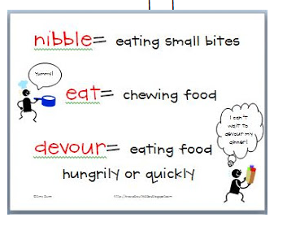
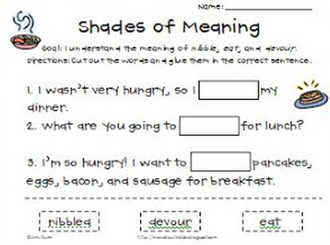
http://www.teacherspayteachers.com/Product/Shades-of-Meaning-for-Verbs-and-Adjectives-Meets-Common-Core-Standard

