Top Ten Center

- Make a list of your TOP TEN

________________________________

- Be sure to skip lines!

- Now, write a complete sentence for each word or phrase on your list. Be sure to capitalize and punctuate!

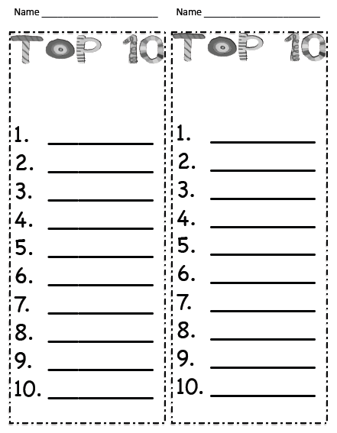

There are MANY Top Ten suggestions on the internet.
This link is to a FREE collection of Top Ten List suggestions linked to Treasures. http://www.teacherspayteachers.com/Product/Top-Ten-Lists

Additional Examples Include:
TOP TEN Book Responses
1. Top ten reasons to read this book.
2. Top ten things, or reasons, I hate or love about my character.
3. Top ten favorite quotes from my book.
4. Top ten questions I would like to ask the author of my book.
5. Top ten lessons I have learned from this book.
6. Top ten places mentioned in my book.
7. Top ten things I wanted to scream out loud about my book.
8. Top ten things I can’t stop thinking about in my book.
9. Top ten other movies, books, magazines and other world events that relate to my book.
10. Create your own top ten list that fits your book!

