Title of Article/Book: _______________________________________________________ Name: ______________________ #: ___
Fact #4: ___________________________________
______________________________________________________________________________________________________________________________
Fact #3: ___________________________________
______________________________________________________________________________________________________________________________
Fact #2: ___________________________________
______________________________________________________________________________________________________________________________
Fact #1: ___________________________________
______________________________________________________________________________________________________________________________

Four Corner Facts

Read the article / book:

starting on page ______

Using complete sentences,
write four facts that you feel help the author clearly explain the main idea.
Then, illustrate what you wrote.

If you have time, write down as many additional supporting facts
as you can on the back of your page.

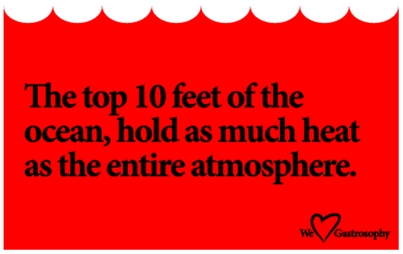
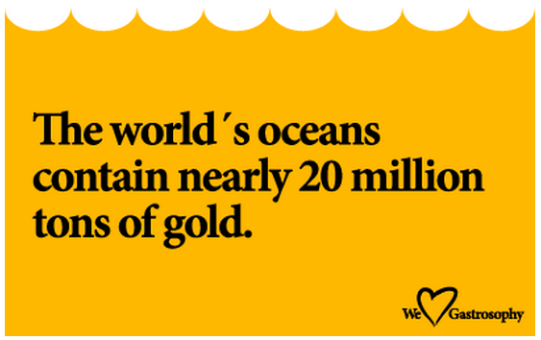

Four Corner
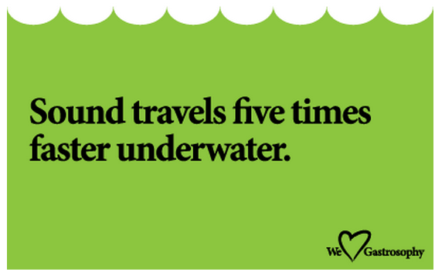
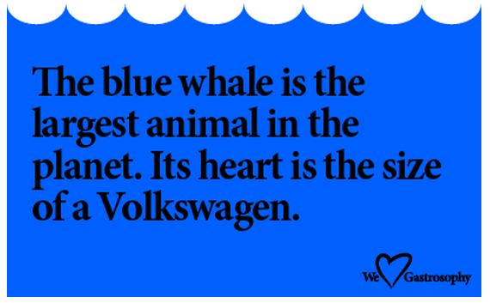
Facts

