Alphabet Soup

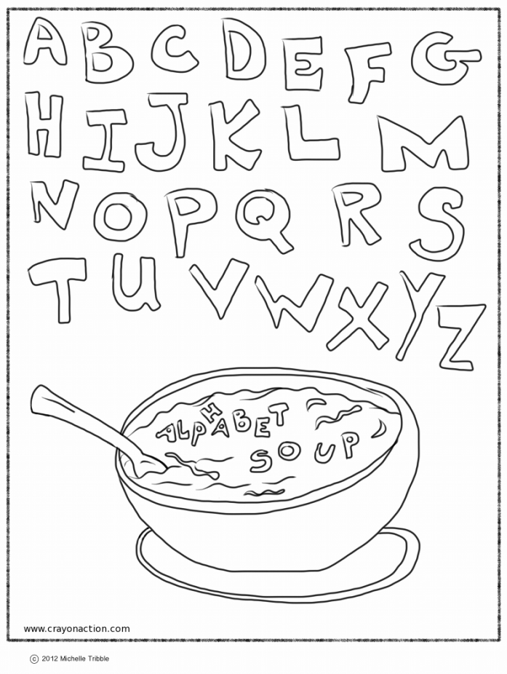

Materials:
- empty DRY water bottle or baby food jar with lid
- rice
- letter beads
- gorilla glue or hot glue for securing the lid
- alphabet sheet
- page protector
- dry erase marker
- sock or eraser

*don’t overfill your bottle, half-full seems to work best*

Students turn/shake/roll the bottle to find the different letters in the alphabet. When they find a letter they mark it off on the sheet.

Name___________________________

Alphabet Soup

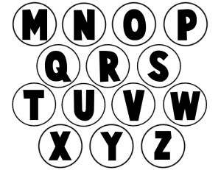
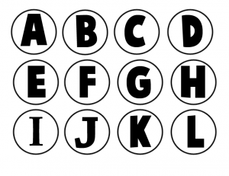

Name___________________________

Alphabet Soup

