Now it’s your turn!

Students take turns reading phrases to improve reading fluency.

The first player draws the cards one at a time
and reads each card until they draw a “Now it’s your turn” card.

This player places all of the cards they read and
the “Now it’s your turn” on the bottom of the stack.

The player to their right begins drawing and reading cards
until they draw a “Now it’s your turn” card.

Play continues until time is up.

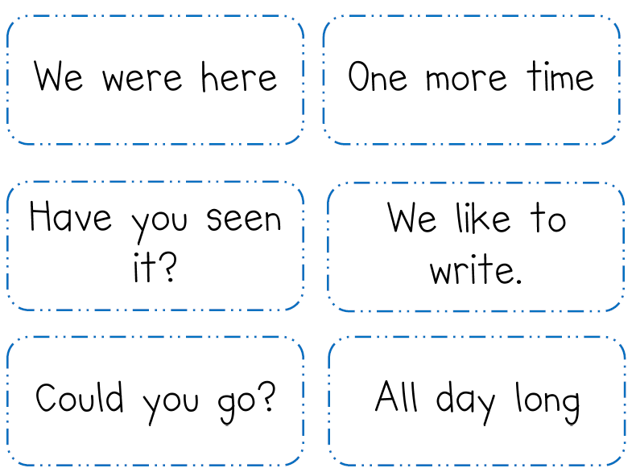
Now it’s your turn!
Now it’s your turn!
Now it’s your turn!
Now it’s your turn!
Now it’s your turn!
Now it’s your turn!

