Directions:
Use Scrabble tiles to spell your words.
In the chart, write your words with letter values.
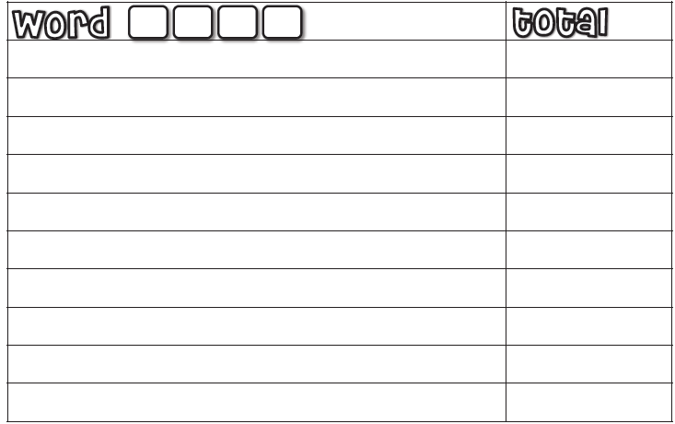
Add each letter value and record the total.
Directions:
Use Scrabble tiles to spell your words.
In the chart, write your words with letter values.
Add each letter value and record the total.

