Stuffed Animal Scripts

Would you like to be the author of a play-
create the story and control the characters?
Follow these steps and you can make it happen.

One day as I walked along
the jungle path, I met a very
strange looking snake.

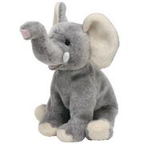

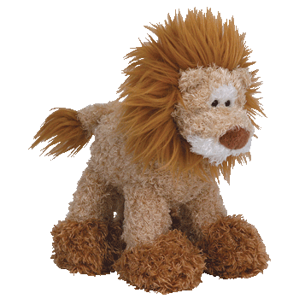

Was his name Randall? That guys is always hanging around trying to cause trouble!

Stuffed Animal Scripts

Would you like to be the author of a play-
create the story and control the characters?
Follow these steps and you can make it happen.

Writing a Two-Character Play

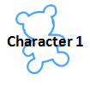
- Select a topic for your story.
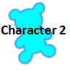
- Brainstorm ideas that connect to that topic. Complete the idea web.

- Write the title of your story- based on the topic. Your title should use five words or less.

- Decide which animal is Character 1 and which is Character 2. Write their names on the Cast of Characters.

- Describe the setting in the blank section of your page.

- Character 1 begins the conversation with 1-3 sentences to introduce the topic. Write these sentences in the first row of the script.

- Character 2 continues the conversation with 1-3 sentences that connect to what Character 1 said. Write these sentences in the second row of the script.

- Character 1 and Character 2 continue to take turns speaking. Each additional line in the script should follow the topic/title and should connect to what was said just before.

- Decide who will have the last line. Character 1? Character 2? Or both characters? Remember- you do not have to fill in every line of the script box.

- The final line of the conversation should connect back to the topic/title and should be a summary of the discussion.

Record your brainstorming ideas here before you begin writing your script.

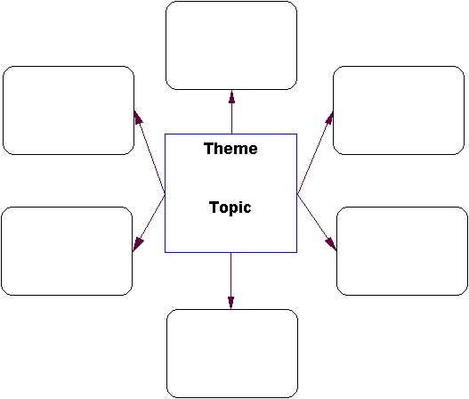
Characters:
Problem:
Ending Events
and Solution:
Middle Events:
Beginning Events:
Setting:

Title
Cast of Characters:
Setting:

Script:

The End
Written By _________________________________________________________________________________________

Suggested Topics for Stuffed Animal Scripts:
(could be assigned, left to studetn choice, or placed in a can to be drawn out randomly.)
- A special birthday I’d like to see . . .

- The biggest thing I ever saw Noisy times and quiet times

- I like to make . . . My adventure

- My favorite foods Picnic fun

- The parade How to make new friends

- Something funny that happened to me Sometimes I wish . . .

- My new friend Games we play at recess

- A trip on a rocket ship The biggest bubble-gum bubble

- Water balloons! Helping out around the house

- Swimming at the pool or lake If I could fly

- What makes me special Who is beautiful?

Additional writing ideas can be found at: http://www.thewritesource.com/writing_topics/more_topics/#away

